- Write a C program to search for an element from the list of elements.
#include<stdio.h>
int main ()
{int i,n,s,num,f=0;
printf("enter the no. of elements:");
scanf("%d",&n);
printf("\nenter the element to search:");
scanf("%d",&s);
for(i=1;i<=n;i++)
{
printf("\nenter the element%d :",i);
scanf("%d",&num);
if(num==s)
{f=1;
printf("\nelement is found at position %d ",i );}
else
{printf("\nelement is not found" );}}
return 0;
}
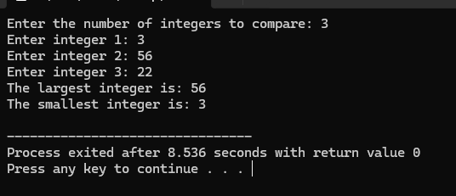
- Write a C program to perform the comparison of two or more integers and display the largest and smallest element.
#include <stdio.h>
int main() {
int n, i, num;
int large, small;
printf("Enter the number of integers to compare: ");
scanf("%d", &n);
printf("Enter integer 1: ");
scanf("%d", &num);
large = num;
small = num;
for (i = 2; i <= n; i++) {
printf("Enter integer %d: ", i);
scanf("%d", &num);
if (num > large) {
large = num; }
if (num < small)
{ small = num;
} }
printf("The largest integer is: %d\n", large); printf("The smallest integer is: %d\n",
small);
return 0; }
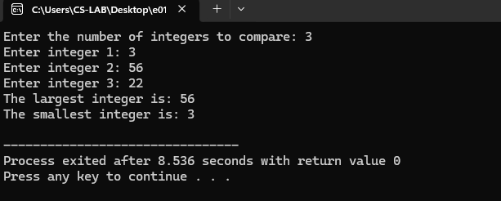
- Write a C program to display the sum of all numbers between 1000 to 2000 which are divisible by 3.
#include<stdio.h>
int main ()
{int i,sum=0;
for(i=1000;i<=2000;i++){
if (i%3==0){
sum+=i;
}
}
printf("the sum of all numbers between 1000 to 2000 which are divisible by 3 is %d",sum);
return 0;
}
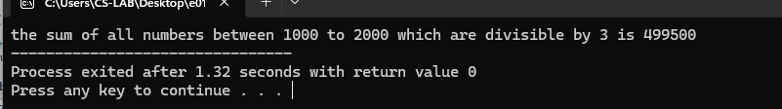
- Write a C program for menu driven calculator using do-while and switch statements.
#include <stdio.h>

int main() {
char op;
float num1, num2, result;

do {
printf("\n Calculator Menu \n");
printf("1. Addition (+)\n");
printf("2. Subtraction (-)\n");
printf("3. Multiplication (*)\n");
printf("4. Division (/)\n");
printf("5. Exit\n");
printf("Enter your choice (1-5): ");

scanf(" %c", &op);
if (op == '5') {
printf("Exiting calculator\n");
break;
}
printf("Enter first number: ");
scanf("%f", &num1);
printf("Enter second number: ");
scanf("%f", &num2);
switch (op) {

case '+':
result = num1 + num2;
printf("%.2f + %.2f = %.2f\n", num1, num2, result);
break;
case '-':
result = num1 - num2;
printf("%.2f - %.2f = %.2f\n", num1, num2, result);
break;
case '*':
result = num1 * num2;
printf("%.2f * %.2f = %.2f\n", num1, num2, result);
break;
case '/':
if (num2 != 0) {
result = num1 / num2;
printf("%.2f / %.2f = %.2f\n", num1, num2, result);
} else {
printf("Error: Division by zero is not allowed.\n");
}
break;
default:
printf("Invalid choice. Please enter a number between 1 and 5.\n");
}
} while (op != '5');
return 0;
}
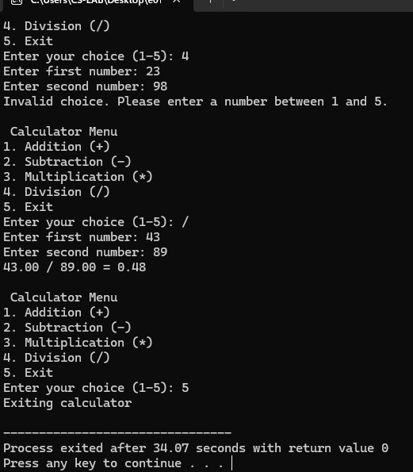
5. Write a C program to find whether the number is palindrome
#include<stdio.h>

int main () {
int n,org,rev=0,rem;
printf("enter the number: ");
scanf("%d",&n);
org =n;

while(n>0) {
rem=n%10;
rev=rev*10+rem;
n=n/10;
}

if(org == rev) {
printf("%d is a palindrome\n",org);
} else {
printf ("%d is not a palindrome\n", org);
}
return 0;
}
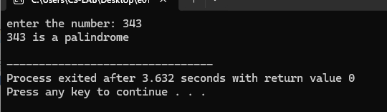
6Write a C program to find the armstrong number. #include<stdio.h>
int main ()
{int n,org,rev=0,rem;
printf("enter the number");
scanf("%d",&n);
org =n;
while(n>0)
{rem=n%10;
rev+=(rem*rem*rem);
n=n/10;
}
if(org==rev)
{
printf("%d is a armstrong",org);}
else {printf ("not armstrong");
}
return 0;
}
7. Write a C program to generate Arithmetic Progression and Geometric Progression series
#include <stdio.h>
int main() {
int n, i;
float a, d, r, term;
printf("Enter the first term (a): ");
scanf("%f", &a);
printf("Enter the number of terms (n): ");
scanf("%d", &n);
printf("Enter the common difference for AP (d): ");
scanf("%f", &d);
printf("Enter the common ratio for GP (r): ");
scanf("%f", &r);
printf("\nArithmetic Progression (AP) Series:\n");
term = a;
for (i = 0; i < n; i++) {
printf("%.2f ", term);
term += d;
}
printf("\n\nGeometric Progression (GP) Series:\n");
term = a;
for (i = 0; i < n; i++) {
printf("%.2f ", term);
term *= r;
}
return 0;
}
8. Write a C program to print the following patterns and numbers
#include <stdio.h>
int main() {
int n;
printf("Enter the number of ROWS(n): ");
scanf("%d", &n);
for (int i = n; i >= 1; i--) {
for (int j = 1; j <= i; j++) {
printf("*");
}
printf("\n");
}
return 0;
}
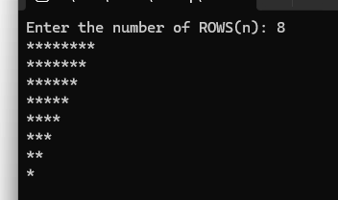

#include <stdio.h>
int main() {
int n,count=1;
printf("Enter the number of ROWS(n): ");
scanf("%d", &n);
for (int i = 1; i <= n; i++) {
for (int j = 1; j <= i; j++) {

printf("%d",count);
count++;
}
printf("\n");
}
return 0;
}
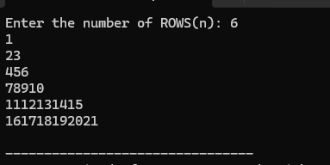

#include <stdio.h>
int main() {
int n,i,j;
printf("Enter the number of ROWS(n): ");
scanf("%d", &n);
for (i = 1; i <= n; i++) {
for (j = 1; j <= i; j++) {
printf("%d",j);
}
printf("\n");
}
return 0;
}
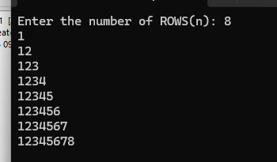

#include <stdio.h>
int main() {
int n,i,j;
printf("Enter the number of ROWS(n): ");
scanf("%d", &n);
for (i = 1; i <= n; i++) {
for (j = 1; j <= i; j++) {
printf("*");
}
printf("\n");
}
return 0;
}
